De Docta Ignorantia
Transgenic Cockroaches as Living Archives

Philippe Codognet

University of Paris 6 *

What could we said about archiving and memory at the time of networks and generalized societies of spectacle, in real-time and live broadcast 24h a day on the Internet ? In a society where everything is becoming virtual (work, money, music, art, etc), it seems that the exchange value of an information is no more its truth or validity but the number of people looking at it - on TV or on the Web, nothing has changed. Archived memory has thus nothing to do with reality but is used as information fuel to feed a cyberspace in search of meaning. And if memories becomes spectacle, spectacle is also becoming memory and archived, as memory theatres - collective or personal - turn to be mere accumulations of immediate cultural signs, ready to be consumed again. Networks, such as the Internet, certainly allows for a better organization, distribution and dissemination of information with respect to traditional panoptic media systems such as radio and TV, but they foremost make it possible to avoid, by favoring the container over the content, inquiring about meaning, in a classical techno-scientific approach.
We will consider in this paper the logical next step after cybernetics and the mechanization of the world : life sciences and biotechnologies, which claim to be improving and perfecting genetic data and bodies, but are also beginning to take their share in the techniques of archiving. The computer seems today, especially with the World Wide Web, the perfect archiving machine, but it could soon be replaced by more compact substrates for storage and maybe even for computation, as wetware will replace hardware. Live organic storage might quickly become more handy and useful than digital archives and the plastic support of CDs or DVDs, or the new « memory stick » by Sony.
There is also a general tendency in contemporary art to shift from technological models to biological models. I will just mention here the current abstract artists from New York such as Jonathan Lasker, Lydia Dona or Fabian Marcaccio (to name but the most well-known), versus an older generation like Peter Halley and his electronic networks and chip-like paintings. Moreover many artists working with new technologies are explicitly referring to Artificial Life and conceive “Art as a living form”, see for instance Karl Sims, Christa Sommerer & Laurent Mignonneau, Louis Bec, or some recent works by Perry Hoberman. Waiting to see a deeper impact of this paradigm shift on our global vision of the world, I would like to evoke a recent and revealing technological project. Among the various celebration for the new millenium, the New York Times and the Museum of Natural History in New York proposed the construction of a metaphorical Time Capsule (the New York Times Capsule) aimed at archiving a snapshot of the state of the world at the end of the second millenium. Such a storage should be kept undisclosed until the year 3000, the end of the 3rd millenium, when our descendants would open this preserved and mummified cross-section of life. The proposal of the Spanish architect Santiago Calatrava won the favors of the jury with a stainless steel capsule based on curvilinear abstract forms that will contain objects from everyday life : mobile phone, dog-food, condoms, photographs and noises of New York City, and some key editions of the New York Times (sponsoring the project).

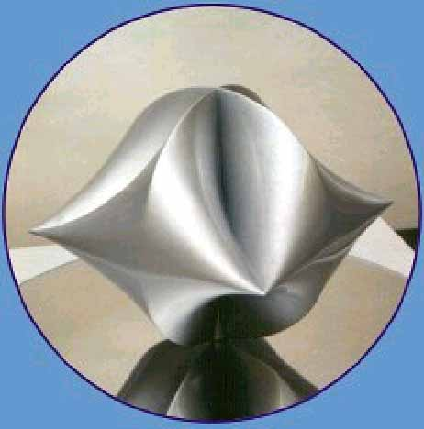
The New York Times Capsule by Santiago Calatrava

We have here a concrete form of “Memory Theater”, echoing the long forgotten Memory Theatre of Giulio Camillo Delminio, one of the most famous humanists of the XVIth century.
But I do not want to spend too much time on this, and rather address a more interesting, and more frightening proposal for the New York Times Capsule, that was indeed rejected.
The project of Jaron Lanier (a mythical hero of the Silicon Valley, pioneer of Virtual Reality and Tele-Presence), consisted in digitizing all issues of the New York Times from 1999 and insert them by genetic engineering into the DNA of New York cockroaches, coding thus the binary computer encoding with the ternary DNA code using the 4 bases : A, T, G, C, (Adenine, Thymine, Guanine and Cytosine).

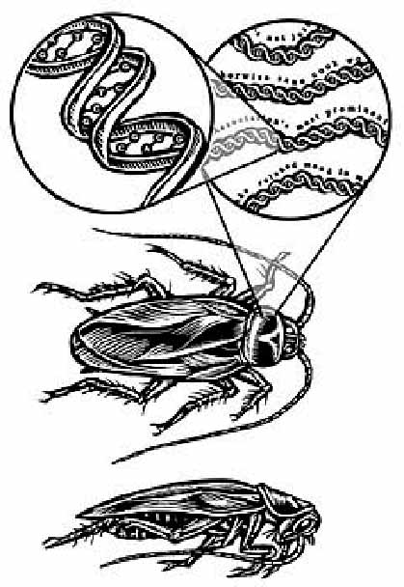

Jaron Lanier’s Archival Cockroaches

To quote Jaron Lanier, who worked on this project together with a biologist from Columbia University : “Once an archive is selected, it will be written into a computer file and coded into DNA base pairs. The sequences will then be synthesized by conventional protocols. Then the archival DNA will be ligated into cockroach intron DNA via injection into eggs”. There are large portions of the DNA, called introns, that seems to serve no known purpose, but they are nevertheless copied from generation to generation. This could be a compact form of storage indeed, self-replicating and self-repairing… Why not use this DNA substrate as a giant Babel Library, in perpetual duplication and regeneration ? Surprisingly, but maybe not so much in fact, this project is technically feasible with today biotechnologies, and can even be budgeted : bio-tech companies charge about half a dollar per base pair for creating DNA sequences. One letter can be coded in ASCII with 8 bits within a computer or 4 base pair within DNA, and thus will cost $2. A page will be about $2,000… How much knowledge could we feed the bug with ? As Jaron Lanier said : “A single cockroach’s introns will easily be able to contain the articles, letters, and other primary texts of one full year’s editions of the Times Magazine. (…) The cockroach easily has over a billion base pairs in its introns, which will have a capacity to represent over 250 million letters. That is far in excess of what is needed for the archive, even with the requirement of redundancy”. Recall that genes only use 3% of the whole DNA, leaving 97% for supposedly garbage introns. Such archiving might be seen as unstable because it will be written over and over in the DNA of each generation. There is therefore a potential risk of mutation that will make it unreadable, but it is quite low indeed because “cockroach’s genes are extremely stable and have not changed substantially for millions of years”, and also because it is easy to have multiple copies that will be compared to give back the original text. Medieval Libraries did not work differently in some sense, with huge Scripture rooms and copyists who were constantly re-writing ancient text to have them better preserved. Cockroaches are very resistant creatures, they have survived all natural cataclysms and could also most probably survive potential human cataclysms like a nuclear war. This transgenic archival cockroaches, multiplied within a few decades or centuries in millions of (nearly) perfect copies would be the quasi-undestructible receptacles of the memory of humanity. “Within approximately fourteen years, the archival roaches will inexorably become so endemic as to become an ubiquitous and permanent feature of the Manhattan island.”, said Lanier.
So, cockroaches as basic blocks of a virtually infinite, distributed and self-replicated archive ? What a librarian dream ! A sphere whose center is everywhere and circumference nowhere, to paraphrase Nicolas of Cues, who was considering in his book De docta ignorantia in 1440 an infinite universe, expanding thus tremendously the closed Aristotelian universe. The learned ignorance of those archival cockroaches, more knowledgeable than the most erudite scholar but unable to decode and access this immense knowledge, brings up a bitter paradox. But could these memory machines, unaware of the information data they contain, marked with the seal of genetic manipulations, with their DNA cut and pasted by wizard doctors up in the NASDAQ, be the future of our memory ? Bugs of knowledge, fed with the dustbin of our commodities and the garbage of our spectacle, mass-storage in search of an improbable interface, they indeed reify in themselves, in their own flesh and blood, the state of our society at the turn of the millenium.
But another question is worth asking. Do we have now, with the genetic code, the ultimate universal language ? This tradition of a universal or perfect language, so vivid in the seventeenth utopian century, indeed goes back to medieval time. More recently, the success of the computer as a universal information-processing machine essentially lies in the fact that there exists an universal language in which many different kinds of information could be encoded and that this language could be mechanized. This would concretize the well-known dream of Leibniz of an universal language that would be both a lingua characteristica, allowing the ‘’perfect’’ description of knowledge by exhibiting the ‘’real characters’’ of concepts and things, and a calculus ratiocinator, making it possible for the mechanization of reasoning. Surprisingly enough - or maybe not - Leibniz is also commonly credited with the invention of the universal language of computers : binary notation. He published its ‘’discovery’’ in 1703, and this started a growing interest in non-decimal numerical systems. But Leibniz’s invention can be traced back to 1697, in a letter to the Duke of Brunswick detailing the design of a medallion.

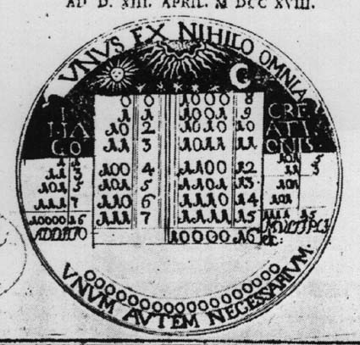
Leibniz’s medallion for the Duke of Brunswick
( from the Postdoctoral Thesis by Johann Bernard Wiedeburg of Jena, 1718)

He delayed its publication until finding an interesting application, and the one he choose was the explanation of the Fu-Hi figures, the hexagrams of the I-Ching, or Book of changes, from ancient China, that have been communicated to him in 1700 by Father Bouvet, a jesuit missionary in China. Two centuries and a half later, binary notation found another application with a much broader impact : digital computers. Although the first computer, the ENIAC machine created in 1946, made use of a notation that was some sort of hybrid between decimal and binary, the application of full binary notation was generalized in the following years, after the Burk-Goldstine-Von Neuman Report of 1947 :
“ An additional point that deserves emphasis is this : An important part of the machine is not arithmetical, but logical in nature. Now logics, being a yes-no system, is fundamentally binary. Therefore, a binary arrangement of the arithmetical organs contributes very significantly towards a more homogeneous machine, which can be better integrated and is more efficient. ”
This report indeed defined the so-called IAS computer design, which formed the basis of most of the systems from the early fifties, that were indeed the first purely binary machines .
But at the same time, another revolution was on its way : 1953 was the date of the discovery of the double Helix structure of the DNA by James Watson and Francis Crick. As shown in a recent book by Lily Kay, Genetics is the daughter of Computer Science and Cybernetics. The scientific concepts put forward in the late 40’s with the development of information theory by Claude Shannon and of cybernetics by Norbert Wiener, at the core of the development of computers, were fundamental in changing the concepts of molecular biology and making it enter the age of information. DNA was thus seen as a “word”, a string of symbols taken from an “alphabet” consisting of the four bases A, T, G, C; and the problem of understanding how the the DNA can produce the 20 amino-acid at the basis of life was considered as a deciphering problem : breaking the genetic code. Symposiums on “Information Theory in Biology” were held, information-theoretic tools were used for a few years by many researchers, but the code resisted until 1961 when Marshall Nirenberg (later Nobel prized, as Crick and Watson) showed that the base sequence TTT was coding Phenylalamine (one of the twenty amino-acid). It will take several more years until the genetic code will reveal all its secrets and thus open the way for the development of bio-technologies as we know them now. The fact that these researchers were convinced of discovering the universal language of live is obvious in their own words. The French biologist Jacques Monod, Nobel Prize in 1965 and champion of the cybernetic approach in molecular biology (he proposed for instance the models of “Cybernétique Enzymatique” and “gène informateur”) said : « La surprise, c’est que la spécificité génétique soit écrite, non avec des idéogrammes comme en chinois, mais avec un alphabet comme en français, ou plutôt en Morse. » Indeed several biologists in the 60’s considered the relationship between the Chinese characters of the I-Ching (64 hexagrams, each composed of 3 digrams, i.e. 3 couples of binary signs) and the coding of the amino-acids with 3 bases in the genetic code (the four bases being coded by 2 binary numbers). We are back to Leibniz again, who used binary notation for explaining the I-Ching in his seminal paper.
But reading the DNA and decyphering it was not enough. David Jackson, a champion of biotechnology said : « To be fluent in a language, one needs to be able to read, to write, to copy, and to edit in that language. The functional equivalent of each of those aspects of fluency have now been embodied in technologies to deal with the language of DNA ».
He is not only looking at a universal language, but he also wants a universal word processor !
Some contemporary artists indeed took this words seriously, or so it seems.
The recent artworks Genesis and GFP Bunny by the Brazilian artist Eduardo Kac (currently living in Chicago) are exemplar in this way. Genesis (showed in 1999 at the Ars Electronica festival in Linz) consisted in a petri box full of bacteria genetically modified in a way close to the proposal of Jaron Lanier.

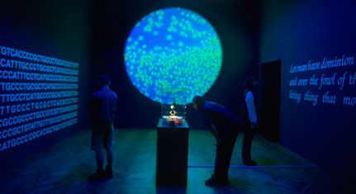

Eduardo Kac, Genesis, 1999

A new gene has been introduced into the bacteria, which was derived from a sentence of the Bible: “Let man have dominion over the fish of the sea and over the fowl of the air and over every living thing that moves upon the earth”. This sentence was first translated into Morse code and then converted into DNA base pairs. Presented under UV lighting, those bacteria can reproduce and mutate and thus modify the sentence of the Bible, which could then be deciphered back into Latin characters… The next step was GFP Bunny (2000, but never exhibited) : an albinos rabbit with a modified DNA containing an extra gene from a medusa (GFP means Green Fluorescent Protein).

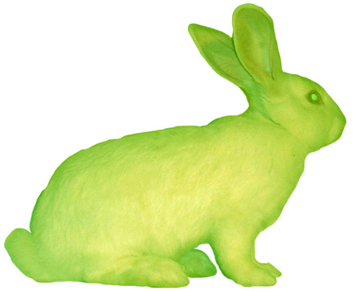

Eduardo Kac, GFP Bunny, 2000

This work was produced by a French research laboratory (INRA) before being appropriated by an artist (although this issue is not completely solved yet). But maybe tomorrow everyone will be able to use some bio-genetic home studio and play Frankenstein over the week-end… Do we simply have here a mere extension of the domain of art with the transgenic world, recalling therefore Duchamp’s gesture which opened Art to readymades in 1913 and shook the foundations of the art world in 1917 at the Armory Show by trying to show a urinal as a sculpture ? But one cannot obliterate the fact that by using a technological process without questioning its very existence, it renders it commonplace, and it accepts the dominant position advocated by the alchemists of life on the innocuousness of genetic manipulations. Who knows the real effects of those DNA changes on rabbits or cockroaches, beyond the reductionist discourse of the scientific and high-tech industry complex ? Even worse, GFP Bunny or the Archival Cockroaches indeed reify frightening perspectives into more acceptable artistic or archiving fields. Art in general, and technological art in particular has always been between collaboration and resistance with respect to the System. If transgenic art is controversial, it is because there is no reflection on the technology put at use. Those works do not question their own medium and therefore might become party to a crime with no name : that of the industrial and commercial use of life, that of genetic slavery.

Notes

* LIP6, case 169, 8 rue du Capitaine Scott, 75015 Paris, France, Philippe.Codognet@lip6.fr
That is to say, within a globally homogeneous and hegemonic Western culture, others will stay at the door…
This theater is precisely described in his book: Idea del Theatro, published in Venice in 1550. See also : Frances Yates, The Art of Memory, Chicago University Press 1990 (first edition: London, 1966), chapter 7.
see www.advanced.org/lanier/roach.html
Forgive me for being too anthropomorphic here …
On this topic, see U. Eco, The quest for the perfect language in Europe, 1995, or R. Pellerey, le lingue perfette nel secolo dell’utopia, Laterza, 1992.
‘’Explication de l’arithmétique binaire’’, Mémoires de l’Académie Royale des Sciences, Paris, 1703.
For a basic history of early computing, see W. Aspray, John Von Neumann and the origins of Modern Computing, The MIT Press, Cambridge, USA, 1990, or P. Levy, "l'invention de l'ordinateur", in M. Serres (Ed.), Eléments d'histoire des sciences, Bordas, Paris, 1993.
A. W. Burks, H. H. Goldstine and J. von Neumann, Preliminary Discussion of the Logical Design of an Electronic Computing Instrument, Institute for Advanced Studies, Princeton, USA, 1947.
Cf. W. Aspray, op. cit.
Lily E. Kay, Who Wrote the Book of Life ? An History of the Genetic Code, Stanford University Press, 2000.
Inaugural address to the Collège de France, 1965. Cited in Kay, op. cit.
See Kay, op. cit.
David Jackson, Template for an Economic Revolution, in Donald Chambers (Ed.) DNA,The Double Helix : Perspective and Prospective at Forty Years, New York Academy of Science Press, 1995.
For more details on the works, see www.ekac.org .

