Artificial Nature and Natural Artifice
Philippe Codognet
Professor of Computer Science
Université de Paris 6
LIP6, case 169,
4, Place Jussieu, 75005 PARIS, France
Philippe.Codognet@lip6.fr

The title of this paper is borrowed from Claudio Tolomei, a sixteenth century Italian humanist from Siena, who used these words to describe the Manierist gardens where natural vegetation was intermixed with human constructions and technological devices : not interactive waterworks but also statues, grottos and “follies”, as for instance in the Orsini garden at Bomarzo. This time was the heyday of the « double oxymoron », linguistic mirror of the stylistic boldness of the manierist painters. Oxymoron that is today revived in the contemporary buzzword : « Virtual reality ».

Virtual Reality (VR) is currently coming out of the research labs to reach mainstream audience. After moving from the textual computer to the flatland monitor in the previous decade, the 90’s has seen the emergence of Virtual Reality as the next technological frontier. Sooner or later all computer interactions will be in three dimensions, even if always through the classical Albertian window of the screen rather than with complex visual or haptic devices. The World Wide Web will also be affected by this revolution, and we will soon change our way of browsing the Internet from surfing flat HTML pages to diving into 3D virtual worlds, that is, virtual spaces where digital communities could meet and experiment new communication media.

I. Virtual Artworks
Some experiments have been already done with VR immersive art installations. These works has been in general realised with new technologies such as CAVE environments (created by the EVL group at the University of Illinois in 1991) or Head Mounted Displays (HMD for short, created at NASA in1984), following the original ideas of Ivan Sutherland (1968) and the forgotten pioneering work by Morton Heiling (1960).
Several artworks based on VR technologies have been created in the late nineties, among which the most well-known works are :
- “Perceptual Arena” by Ulrike Gabriel, Cannon ARTLAB, Tokyo, 1993
- “reConfiguring the CAVE” by Jeffrey Shaw, Agnes Hegedüs and Bernd Lindermann, ICC (Inter Communication Center), Tokyo, 1997
- “Osmose” (1995) and “Ephemere” (1998) by Char Davies
- “Icare” by Ivan Chabaneau, CICV (Centre International de Creation Video), Montbeliart, France, 1997
- “World Skin” by Maurice Benayoun, Ars Electronica Center, Linz 1998
- “Traces” by Simon Penny, Ars Electronica Center, Linz, 1999
Close to these apparatuses are the use of circular projection walls surrounding the spectator and creating an interactive virtual environment, exemplified in Jeffrey Shaw’s “Space - a user’s manual” (1995), a richer version of his famous “Legible City” (1988-1991), and Agnes Hegedüs’s “Memory Theatre” (ZKM, Karlsruhe, Germany,1997). These devices are indeed downsized versions of Jeffrey Shaw’s earlier project EVE (Expanded Virtual Environment), initiated in 1993, which is a large semi-spherical projection dome on which video are projected, following the spectator head tracking.
A cheaper version of virtuality is feasible within the flat monitors of standard computers : 3D worlds rendered with the VRML description language (Virtual Reality Modeling Language) and displayed with an adequate browser. This medium has already been used in some artworks such as “suspension” by Jordan Crandall and Marek Walczak (Documenta X, Kassel, Germany, 1997) or the Web version of “Icare” by Chabaneau (also online in 1997).

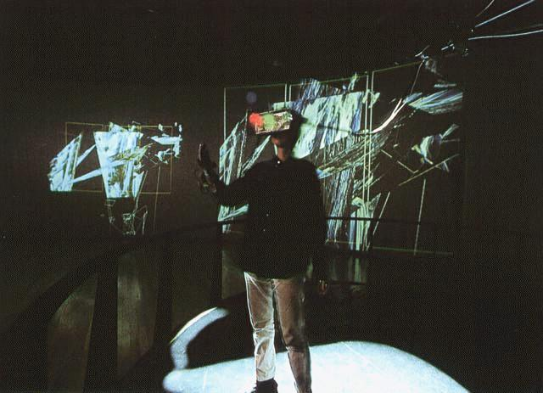

Ulricke Gabriel Perceptual Arena, 1993

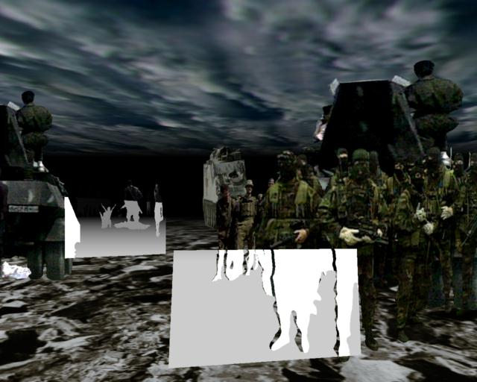

Maurice Benayoun, World Skin, 1998

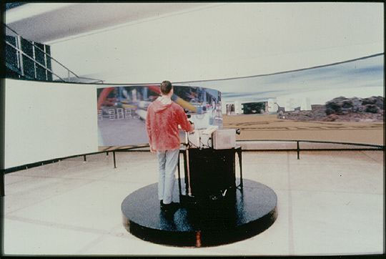

Jeffrey Shaw, Space - a user’s manual, 1995

In a scientific context, VRML technology has been used for creating modern Wunderkamern (curiosity cabinets) and representing, as in the Renaissance, the microcosm and the macrocom, that is the depiction of the human body (and its inside) and the cosmos, see for instance the 3D reconstruction of the Mars landscape by NASA and SGI from pictures taken by the Mars Explorer.

One should nevertheless distinguish between the two apparatuses mentioned at the beginning of this talk, the CAVE and the HMD, as they seem to be used for different purposes in artworks. CAVE or CAVE-like environments are used to represent virtual (but Euclidean) spaces (e.g. Space - a user’s manual by Jeffrey Shaw), whereas works using HMD are more oriented towards abstraction (e.g. Ulrike Gabriel’s perceptual arena).
Is there here a dichotomy between a perspectivist outside space and an inner abstract self ?

II. The prehistory of Virtual Reality
Let us now rewind Time and investigate the historical background of these apparatuses, in particular the Renaissance.
First of all, the castellum umbrarum , castle of shadows, designed by the venetian engineer Giovanni Fontana in his manuscript (bellicorum instrumentum liber, 1420), which can be best described as a Pre-CAVE installation. This is a precise description and depiction of a room with walls made of folded translucent parchments lighted from behind, creating therefore an environment of moving images. Fontana also designed some kind of magic lantern to project on walls life-size images of devils or beasts. The use of projected images on walls was later developed by one of the major figure of baroque humanism, the Jesuit father Athanasius Kircher, « master of a thousand arts », in his book Ars magna luce et umbrae (1646).

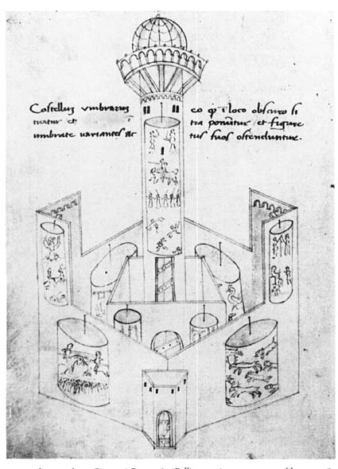 | 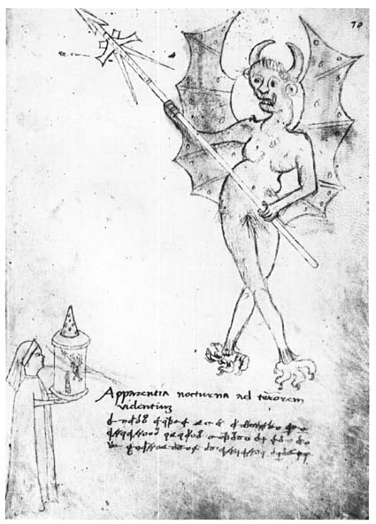

Giovanni Fontana, Bellicorum instrumentum liber, 1420

The second historical background of virtual environments can be found in trompe l’œil frescoes in Venetian, Florentine or Roman villas in the Renaissance : for instance the ”Perspective Room” by Baldassare Peruzzi in the Villa Farnesina (Roma, 1510), the “Giants Room” by Giulio Romano in the Palazzo Te (Mantua, 1530-32) or the frescoes of the Villa Barbaro by Paolo Veronese (near Treviso, 1561). In the Perspective Room, false windows open on a fictitious painted landscape, as an acme of perspectivist and illusionist virtuosity. Leonardo himself also worked on such pictorial schemes and one of his codex contains a drawing describing how to illusionary project a painting on a cubic volume in order to recreate a non-distorted image, a device put at use much later in an electronic manner by the conceptors of the CAVE immersive 3D environment at the University of Illinois …

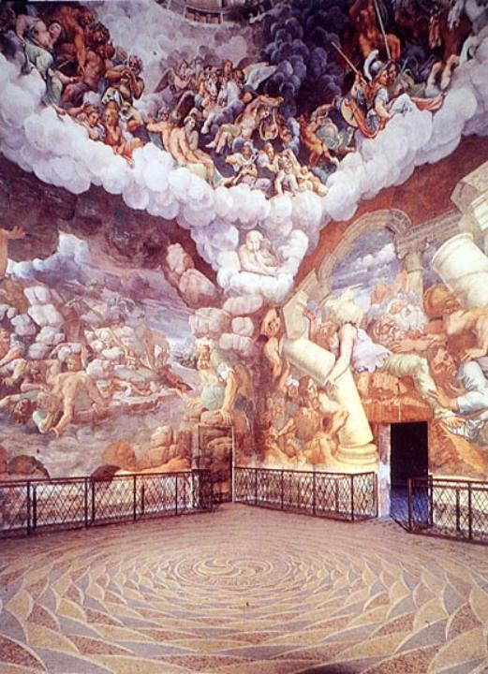
Giulio Romano, Giants Room, Palazzo Te, Mantua, 1530-32.

Hence, immersive environments creating a fictitious or illusory ‘virtual’ space by projecting images onto the walls of a closed room have been investigated for quite a long time, though new technologies give a new impetus because of the ease of creation and of the « realism » of the constructed space. Another point, that we will develop much more deeply later is the interactivity introduced by the possibility of moving within the environment.

The second type of apparatus is the HMD, where the user/spectator is totally cut from the real world and immersed within the fictitious space that in projected on two small monitors in front of the eyes. This device became the allegorical emblem of virtual reality, the symbol of high-tech art for the general public. The idea that the user/spectator is immersed within himself is certainly not alien to the success of this contemporary icon. Let us rewind the tape of history and look back at the tradition of this concept.
Gotfried Wilhelm Leibniz (1646-1716) is a key philosopher to understand contemporary changes in our society. Not only is he credited for the invention of binary notation and the birth of symbolic logic, which are both at the conceptual basis of modern computers, but his baroque philosophy also prefigured many aspects of post-modern ideas.
Gilles Deleuze in his study on Leibniz considered that the closed room, without any windows, is the best visualization of the Leibnizian concept of the monad (cf. Monadology, 1714), and is to be best exemplified in baroque art by the architectural design of the studiolo, for instance that of Francesco I da Medici in the Palazzo Vecchio (Florence, 1570-72). A monad is an entity, a soul « without doors nor windows » containing the whole world ‘folded’ within itself, representing “a subject as metaphysical point”, to use Deleuze’s own words. In a similar manner the studiolo contains the whole world (metaphorically) painted on its walls. Another philosopher used the concept of the monad one century before Leibniz : Giordano Bruno (de triplici minimo et mensura, 1591). For Bruno, the metaphor of the philosophical quest for knowledge is best expressed by the myth of Acteon (De gli eroici furori 1585) : Acteon, having seen Diana nude during her bath, is chased by her dogs and made blind to punish him for having seen such a beauty bound to secrecy. According to Bruno, the philosopher has also to become blind and close his eyes to find the ultimate truth within himself, cut out from the bodily sensations. A direct representation of those ideas can be found in Ripa’s Iconologia, where metaphysics is represented as a blindfolded allegory (here in Jean Baudoin’s version of 1644). A similar picture is associated to the concept of ‘soul’ in the work of the Czech humanist Comenius (Jan Amos Komensky) in his book Orbis sensualium pictus quadrilinguis (1658), « the painting and nomenclature of all the main things in the world and the main actions in life », i. e. a pictorial dictionary. Images are «the icons of all visible things in the world, to which, by appropriate means one could also reduce invisible things ». Soul is thus actually depicted as a veiled head.

Cesare Ripa, Iconologia (French edition by Jean Beaudin, 1644)

Could this be a plausible background, a cultural archetype, for the success of the HMD imagery as the mean to dive into a virtual world within oneself ? Moreover, does this HMD imagery suggest a deep melancholy, a sour regret, for the loss of metaphysics in our modern world ?

III. The spectator’s point of view
An important characteristic of virtual environments (VE) is the possibility for the spectator to interactively move within such spaces, and perceive the virtual world as through a subjective camera. In some sense the spectator becomes an actor, although it can usually do little more than just wander around. This moving, first-person perspective is for some artists an answer to the critic of modern perspectivism, mimesis and “realism” of their works. An important point to note here is that we are changing from the cartographic paradigm to the ichnographic paradigm. The idea of the « cartographic eye in art » appeared recently to reconsider modern art in the twentieth century. This concept is especially relevant for the late and post-modernism in America (Jasper Johns, Robert Morris, Robert Smithson). But with VE we are moving away from the metaphor of the map to that of the path, from the third person point of view (« God’s eye ») to the first-person point of view. As Morpheus said to Neo in the blockbuster movie The matrix (1999), « There is a difference between knowing the path and walking the path ». We are thus leaving the Cartesian paradigm of an Euclidian, homogeneous and objective space in which points could be described by a triple of (x,y,z) coordinates for a new paradigm of a more subjective, and indeed constructive space. This is indeed a return to the ideas of the French mathematician Henri Poincaré (1854-1912), founder of modern topology, who considered that a point in space should be described by the transformation that has to be applied to reach it. Hence space is represented as a set of situated actions. No one knows the totality of the map, no one can picture or order the territory in any comprehensive way, even abstractly. The complexity of the structure (“graph” to follow the word of Michel Serres, “rizhome” for Deleuze, or “network” in the modern terminology) cannot be conceptually apprehended nor depicted. It is worth noticing that, by moving from 2D to 3D, some information is lost. First, because there is never a full blown representation (such as the map). Second, 3D implies hidden surfaces, that is, a “part maudite” (Bataille), the devil’s part, which will always be unknown. There is never light without shadows, nor life without death, as in the Baroque world.
This paradigm shift also appears in recent video artworks and best exemplified by artists like Pipilotti Rist (in her videos, e.g. Pickelporno 1995, or installations such as Ever is Over All, Venice Biennale 1997). Some works of Bill Viola also show the same conceptual changes, for instance the Nantes’ triptych.

Another area closer to VR that showed the same paradigm shift is 3D computer games. The subjective camera also revolutionized the world of computer games a few years ago with DOOM (PC CD-ROM, 1994). Although the game was incredibly simple (hunt-and-kill) and the computer graphics quite poor, the immersive effect was fully operational, even too much for some people. The user/spectator was completely involved mentally, not to say physically, within the VE. However by looking to recent developments, e.g. blockbuster games such as the Tomb Raider series, one can only feel like a step back in the gaming industry away from subjectivity : in TR, the player is behind a camera that follows the heroin (cyberstar Lara Croft) as in a cartoon, he is not playing himself. Similar third-person, TV-like cameras are also hardwired in systems such as Sony’s Playstation or Nintendo 64 console . Considering the history of movie films, one has to admit that the subjective camera device, has been used very scarcely since the 40’s, and was never well received by the general audience. The most famous film of this genre being Robert Montgomery’s Lady in the lake (1947), and in fact the only one to have entered the cinema anthologies. Let us hope that the use of the first-person point of view in VR artwork will have a better fate, but we are maybe bound in today societies of the hegemonic spectacle to what Jean Baudrillard called more than thirty years ago the myth of the consumed vertigo ( « Mythe du vertige consommé »), that is the lure of a second hand experience.

Nevertheless, if a moving viewpoint might be richer than a classical one-point perspective viewpoint, we should not forget the importance of simultaneous viewpoints or privileged viewpoints. For Leibniz, if there are multiple ways of perceiving reality « as the multiple perspective views of a city », corresponding to different “truths”, there is always a particular point of view which is better to understand the whole thing. For instance in geometry, the apex of the cone, from which all the conic curves are intelligible. This idea of a specific viewpoint is also at work in baroque perspective art such as the famous ceiling frescoes by Andrea Pozzo in the Church of Sant’Ignazio in Roma (1691-94) which are to be seen from a special point indeed inscribed in the floor of the Church. In other positions the illusionist architecture depicted in the frescoes goes into incoherent strands and seems close to fall down. Some authors have proposed a detailed analysis showing why this perceptually differs from classical perspective paintings on canvas. But what is important here again is the presence of a precise point where everything is in order and takes sense. This point where the illusion is perfect might be the one where one understands the lure of representation and maybe the fragility of reality. In contemporary art, artists rather use simultaneous, fragmented, multiple viewpoints to show up the complexity of their discourse. An immediate example of this is Joseph Kosuth’s well-known work “one and three hammers” (1965), showing a hammer, a photography of this very hammer and a dictionnary definition of a hammer. The simultaneous viewpoints on objects might be contradictory, to better ask the spectator about the “reality” of the depicted object, for instance in René Magritte’s “Ceci n’est pas une pipe” (1926).

IV. Interactivity, shared spaces and multi-user environments
Interactivity is indeed very limited in VE : in most of the so-called ‘interactive art’ only simple binary relations with objects (on/off) are usually implemented. That is, whenever the user moves to some point or touches an object, something happens. Recent new edia exhibitions have shown that the involvement of the spectator in interactive artworks is quite limited indeed, as his role is but to choose between a small number of possibility offered by the computer. There is only a limited and predefined dialogue between the spectator and the artwork. Could we have new modalities of interaction ? Could we go beyond (or below) the mediation of language or simple gestures ? Music or intuitive game-rules are simple examples of this, more complex device could be for instance to interestingly interact within artistic virtual worlds populated with artificial autonomous creatures. But a richer interaction would first require a real integration of the spectator in the artwork, which is not the case at present. In particular issues such as identity, self perception and the gaze of the Other are rather absent from VR works. There is a deep schizophrenia between the real and the virtual world, whatever the complexity of the technical devices (HMD, data-gloves, 3D sound) could ever be. We should nevertheless note that these questions are at the core of the contemporary reflection in art : let us only mention several video works of Gary Hill where the spectator is gazed at by the characters in the video movie and some works by Bill Viola, in particular slowly turning narrative, where the spectator is in some sense integrated into the artwork through a slowly turning mirror/screen, and refer more broadly to the omnipresent use of mirrors in paintings and/or installation art.

A new path to investigate for enlarging the degree of interactivity of new media artworks is the field of shared VE, where several users/spectators can enter the same digital space, for instance by the means of Internet connections, and therefore start an interaction between their ‘avatars’, i.e. their incarnations in the virtual world. This technology is currently used as an infrastructure for creating digital communities and meeting spaces where people basically do nothing else than chatting. This could be seen as a 3D version of the textual MUDs (Multi-User Domains) of the early nineties. Nothing prevents to use the same medium with a richer content in order to design complex interactions in artistic works. It possible to involve the spectator in a deeper way and to provide more complex experiences, such as including the user/spectator within the artwork itself. Indeed, virtual art spaces are fields of interactions, both between the artwork and viewers and between spectator themselves.
An example of this, not in the domain of VR art but which could be a model for many future works, is the installation “Resonance of 4” by the Japanese artist Toshio Iwai (1994). It is composed of 4 computer booths, to be used simultaneously by 4 spectators. Each person can produce some music, a simple melody entered in the computer via a grid-like device. But the overall point of this work is that spectators have to intuitively become aware that they are not alone in the installation but have to initiate some musical dialogue and co-operation to tune their melodies, whether in a consonant or dissonant way. Therefore the real signification of this artwork is the dynamics that can be created among spectators by using a simple interactive scheme such as music.
The core meaning of the artwork is thus an emergent behavior between the spectators. The artist has to create a playground and some adequate set of evolution rules in order to have this interaction to emerge. Meaning is thus not constructed by the artist and interpreted by the spectators, but fully and autonomously constructed by the spectators.
We therefore have to find new models and new concepts for thinking this complexity : self-organisation, emergent properties and autopoiesis, cf. the woks of the late Francisco Varela.

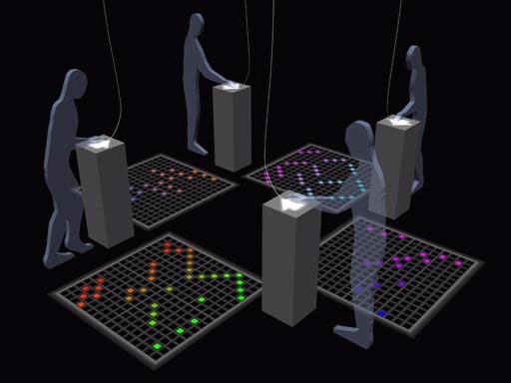

Toshio Iwai, Resonance of 4, 1994

cf. Horst. Bredekamp, Vicino Orsoni e il Sacro Bosco di Bomarzo, Rome, 1989.
cf. Antonio Pinelli, La Belle Manière: Anticlassicisme et manièrisme dans l’art du XVIè siècle, Paris, 1996.
We obviously refer here to Leon Battista Alberti (1404 - 1472), architect, painter and first theoretician of the linear perspective in his book De pictura, 1435. Alberti developed the metaphor of the painting as a window open onto the world, or more precisely onto the historia.
The acronym CAVE stands for Cave-like Advanced Virtual Environment.
see Martin Kemp, Temples of the body and temples of the cosmos, In: B. Baigrie, Picturing Knowledge, Toronto University Press, 1997.
cited in S. Y. Edgerton, The heritage of Giotto’s geometry, art and science on the eve of the scientific revolution, Princeton University Press, 1991.
Cf. M. Kemp, The Science of Art, optical themes in western art from Brunelleschi to Seurat, Yale University Press, 1990, in particular the drawing on page 50.
private discussion with Dan Sandin and Tom de Fantis, the main designers of the CAVE system.
“Explication de l’arithmétique binaire”, Mémoires de l’Académie Royale des Sciences, Paris, 1703. Leibniz considered his discovery to be imago creationis, that is, at the image of the Creation because all numbers can be engendered from the Nothingness and the One …
Gilles Deleuze, Le pli, Leibniz et le baroque, Editions Galilée, Paris, 1988.
Because he must always stay under the control of the devices devoted to interaction : electro-magnetic sensors, optical or infrared cameras, etc. All the (nowdays) classical surveillance machinery is also at work in the virtual worlds …
That is, based on the notion of path.
see the book by Christine Buci-Glucksmann, l’œil cartographique de l’art, Galilée, 1996, and also the catalogue of the exhibition “Mapping”, Museum of Modern Art, New York, 1994.
On Art and Video Games, see my essay “Nijikon Fetchi”, in Catalogue de la Biennale de Lyon, Réunion des Musées Nationaux, 2001.
Interestingly, this causes some schizophrenic choice : one has to choose in the beginning of the game if sound is to be calculated from the gamer’s point of view or from Lara’s…
this point has been developed by Lev Manovich, proceedings of the Imagina Conference, Monte-Carlo, 1998, and his new book, The Language of New Media, MIT Press 2001.
In experimental cinema, one should also mention the great constructivist film Man with the Movie Camera (1929) by Russian director Dziga Vertov (Denis Arkadievitch Kaufman, 1896-1954).
Jean Baudrillard, La Société de Consommation, Editions Denoël, Paris 1970.
see Michael Kubovy, The psychology of perspective and Renaissance art, Cambridge University Press, 1986.
See for instance H.Maturana and F.Varela, Autopoiesis and Cognition: The realization of the living, D.Reidel, Boston, 1980, and F. Varela, E. Thompson and E. Rosch, The Embodied Mind : Cognitive science and human experience, MIT Press 1991.

